# Warlords of War

Warlords of War is an **autobattler card game** with simultaneous turns.

Your goal is to play cards on your board to build the strongest board possible.

Every round, you will **attack** a random player and gain points if you win.

The first player that gets 7 points ahead of everyone wins.

This is what a board might look like:

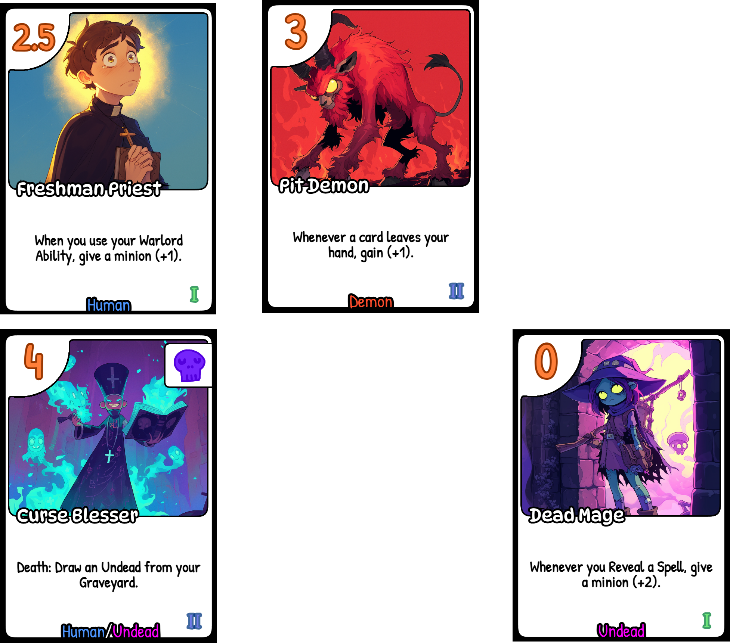

## Setup

There are 3 decks of cards. The decks are Tier 1, Tier 2 and Tier 3.

Separate them.

Each player gets a **Warlord hexagon** and draws 3 Tier 1 deck cards.

**Warlords** look like this:

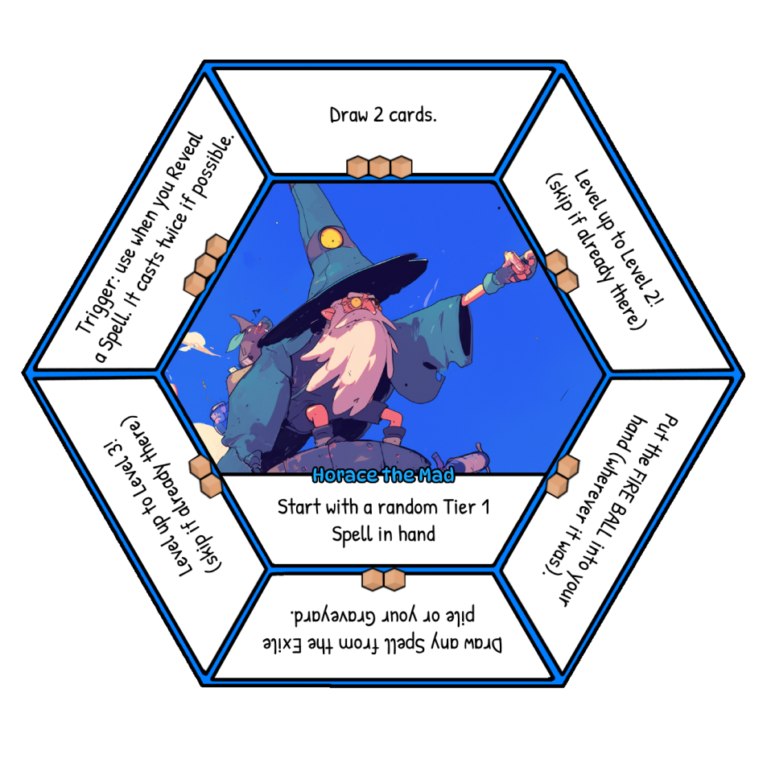

# Gameplay

Players take turns **at the same time**.

At the start of each turn, each player draws 2 Tier 1 cards, then gives one card from their hand to a neighbor player.

## Play Phase

Your board is split into **3 imaginary columns** called **lanes** and **2 rows:** lane 1, lane 2 and lane 3.

Every turn, you can play 2 cards from your hand **face-down,** anywhere on your board (e.g. on any column).

*The minions on your leftmost lane are always considered lane 1, the minions on the next lane to the right are lane 2, etc. 3 lanes of 2 rows = your board has maximum 6 spaces for cards.*

Each card has a **power** (top-left):

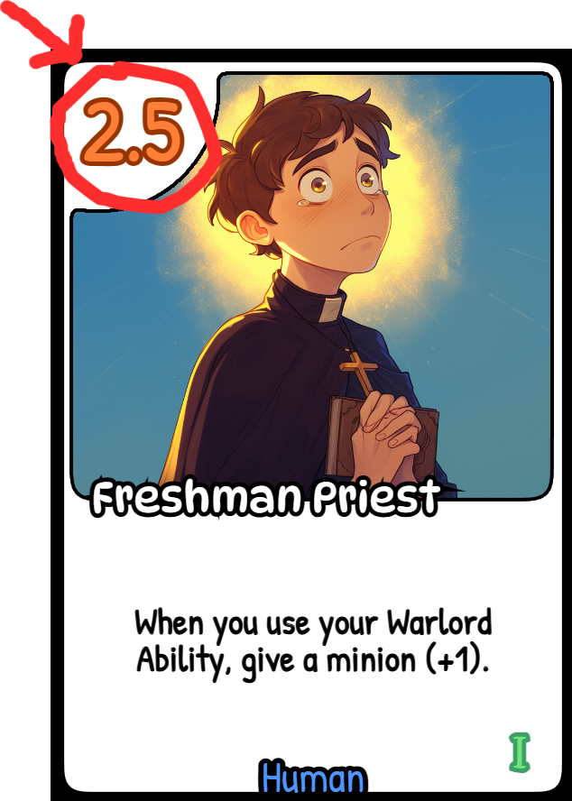

## Reveal Cards

Once everyone has played their cards, everyone reveals their cards at the same time (or in any order).

## Combat

After Reveal, the combat phase begins.

Each player will **attack a random player.**

We use an app to see who attacks who.

Each of your **lanes** has the combined power of its cards.



In this example, lane 1 has 6.5 power, lane 2 has 3 power, lane 3 has 0 power.

When you **attack**, you compare each of your lanes with the enemy lanes.

Your lane 1 with their lane 1, your lane 2 with their lane 2, your lane 3 with their lane 3.

For each lane that has more **Power** than the enemy lane, gain 2 points.

For each draw, gain 1 point.

Combats can happen at the same time.

## Slide Up

After everyone is done fighting, everyone slides up the cards from the back row to the front row (except spells, spells are destroyed).

If you ever put a **card over another card**, the card at the bottom is **destroyed** and goes to your **Graveyard** (e.g. sliding from back row over a front row, playing a face-down card over another card, etc).

## Repeat

A new turn starts and you go back to the Draw phase.

# Warlords

Your warlord has 1 game start power. This is applied when the game starts.

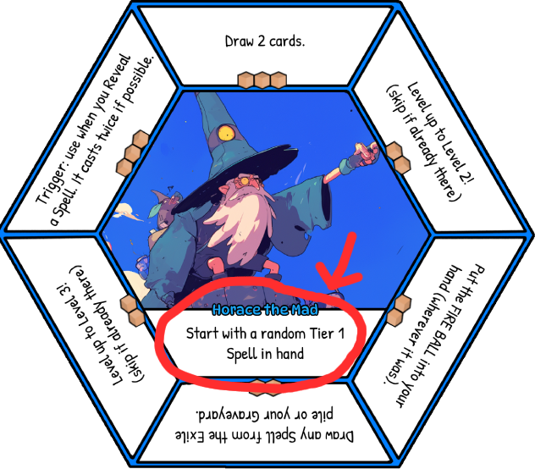

At any point during the **Play Phase**, you may activate the **top power only** from your warlord.

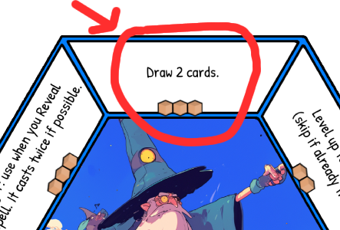

BUT your power has a price. The price is the **brown cardboard boxes** below the text.

In this example, to “**Draw 2 cards**” you must pay **3 Cardboard**.

**Cardboard is cards.**

**1 Cardboard = 1 card from hand, 1 card from Graveyard, 1 face-up card from board or 2 points**

To pay the cost, take your Cardboard and **THROW THEM OUT OF THE GAME**. This is called Exiling cards.

After you activate your power, turn your Warlord hexagon to the next power on the right. That becomes your new power.

## Leveling Up

Most Warlords have a power that will let them **Level Up**.

If you Level Up to Level 2, it means you can now draw from the Tier 2 deck. If you Level Up to Level 3, it means you can now draw from the Tier 3 deck.

# Effects

Cards have effects and text.

Try to guess when a **Reveal, Death, On Turn End, etc** effect activates :)

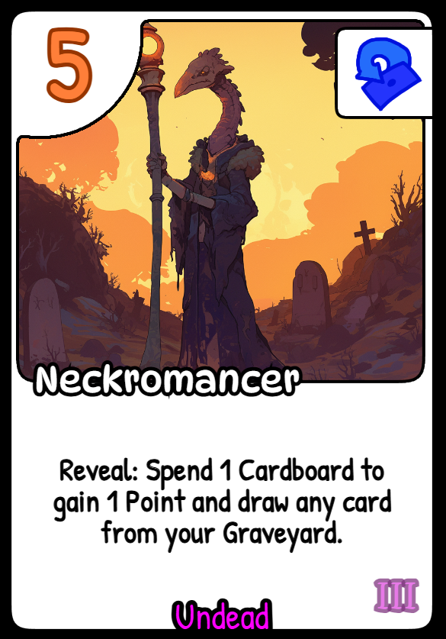

# Buffs/Debuffs

Some cards may give other cards power.

To keep track of it, we use number tokens:

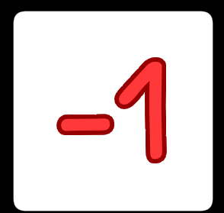

# Tips

Some rules of the game are not stable and might change.

Use your warlord powers! They are very powerful. Once you finish all 6 of them, you go back to power 1 but skip Level Ups. Do it!

Be careful not to accidentally destroy your own minions at slide-up phase. If you put a minion under another minion, when the one below will slide up, the one above is destroyed with all the buffs it had.

Cards from Tier 1 are more about economy (e.g. drawing cards, getting cards, etc). Cards from Tier 2 are all about long-term power. Cards from Tier 3 are about big raw power.